Name: K. Praveen Kumar

Assignment-7

**CSV:**

* CSV stands for comma separated values.
* It is the simplest form of storing data in tabular form as plain text.

**Structure:**

yearsExperience,salary header

1.1,39493.00

1.3,46205.00

1.5,36656.00 observations/records

2.0,14464.00

2.1,49886.00

The first line of a CSV file is the header and it contains the names of the fields which are shown on top as the column names in the file.

**List of methods to read a CSV file:**

**1.read using csv.reader**

**2.read using .readlines() function**

**3.using pandas**

**4.using csv.DictReader**

**1.reading a csv file using csv.reader:**

Step1: Import the CSV library.

Step2: open the CSV file

Step3: use csv.reader object to read csv file

Step4: create an empty list called a header and use next() method to obtain header.

Step5: Extract the rows/headers.

For this create an empty list called rows and iterate through the csv reader object and append each row to the rows list.

Step6: close the file. Close() method is used to close the opened file. Once it is closed, we cannot perform any operations on it.

We might forget to close an open file. To avoid that we can use with() statement to automatically close the resources.

**Code:**  
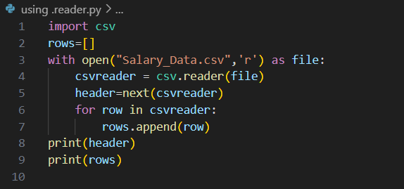

**Output:**

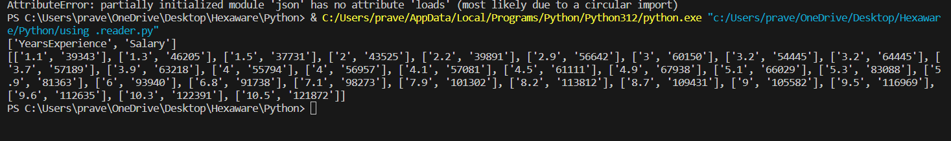

**2. Reading a CSV file Using .readlines():**

It returns all the lines in a file as a list. Each item on the list is a row of our CSV File.

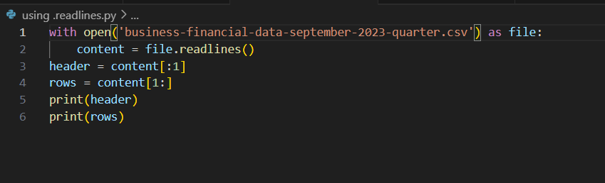

**Output:**

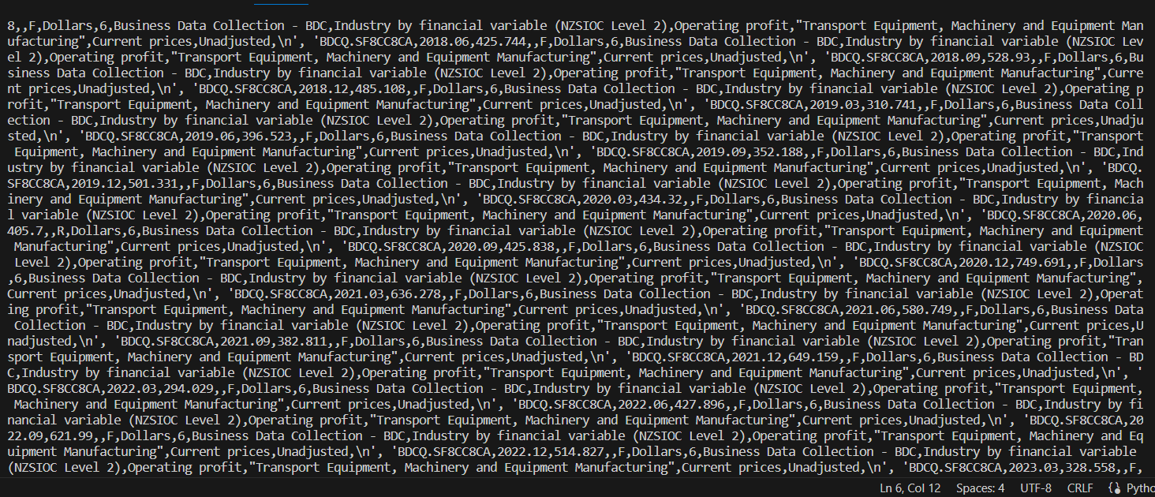

* The ‘\n’ from the output can be removed using .strip() method.

But if we are having a huge dataset with hundreds of features and thousands the pandas library comes into the picture.

**3.Using Pandas:**

Step1: Import pandas as pd

Step2: load CSV files using

Syntax: data= pd.read_csv(‘file name’)

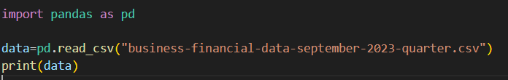

Output:

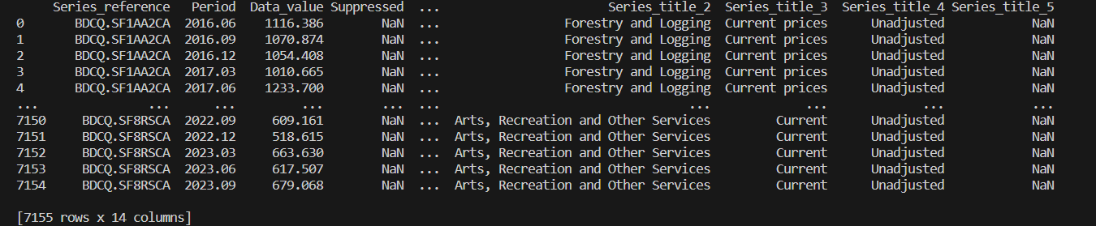

Step3: extract the field names

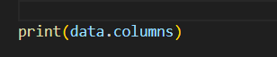

**Output:**

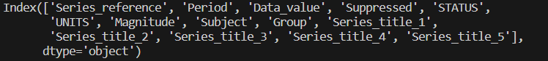

Step4: Extract the rows



Output:

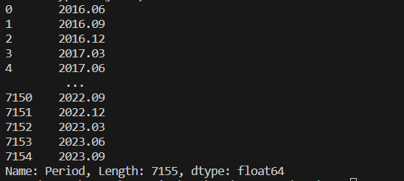

**4.Using csv.DictReader:**

1. Import csv

2. with open(‘filename’,’mode’) as filename:

3. reader= csv.DictReader(CSVfile)

4. for row in reader:

Print(row)

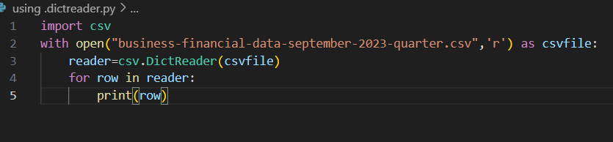

Output:

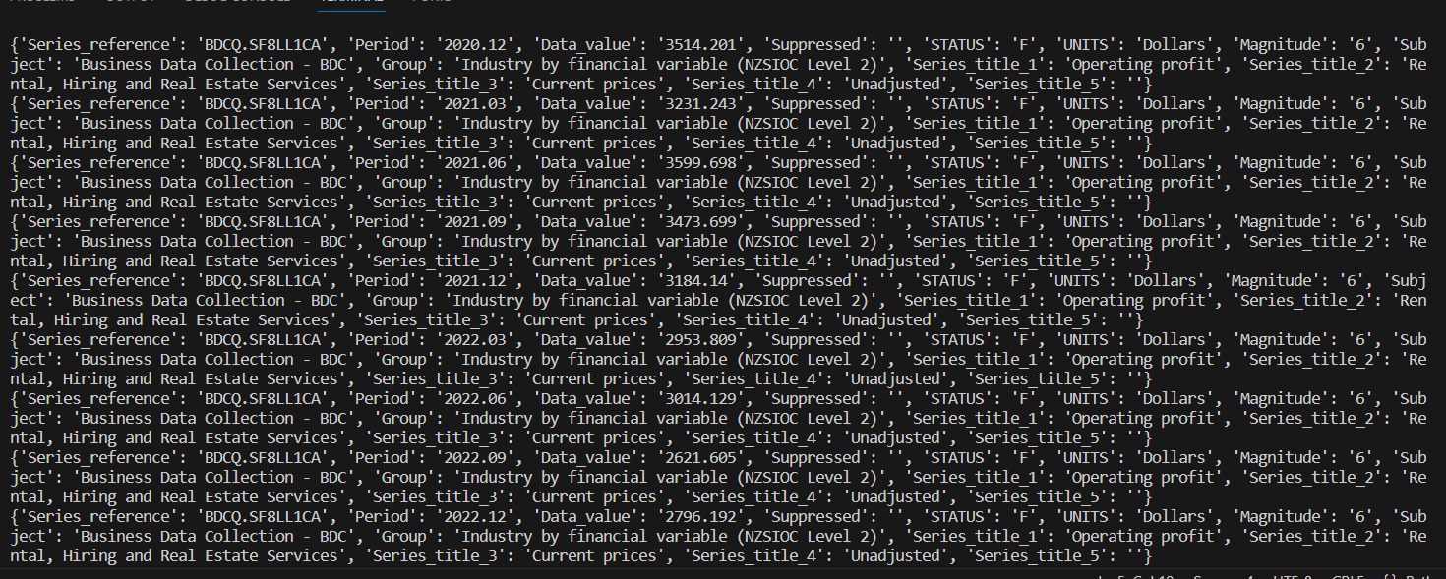

**Methods to write a CSV File:**

**1.write csv file using csv.writer**

**2.write csv file using writelines() function**

**3.write csv file using pandas**

**4.write csv file using csv.DictWriter**

**1.Using csv.writer:**

Step1: Import csv library

Step2: Define a filename and open the file using open()

Step3: Create a csvwriter object using csv.writer()

Step4: write the header

Step5: Write the rest of the data

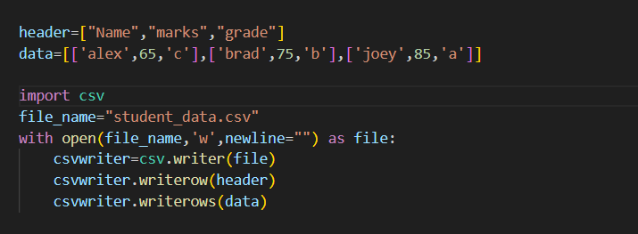

Output:

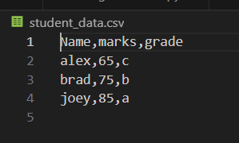

**2.Using .writelines():**

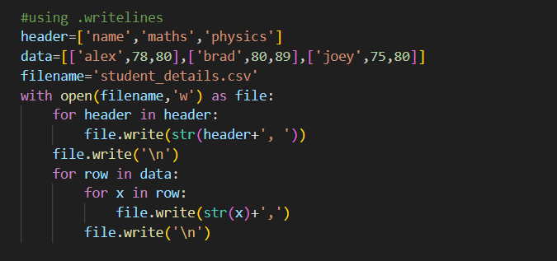

**Output:**

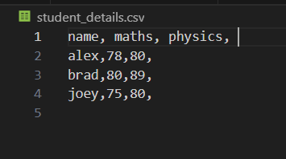

**3.Using Pandas:**

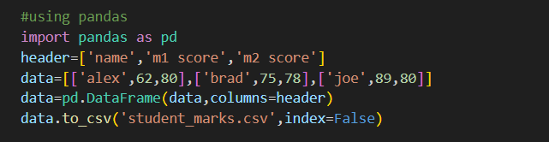

**Output:**

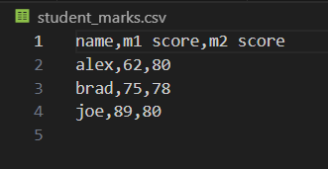

**4.Using csv.DictWriter:**

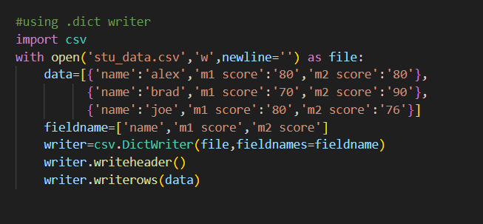

**Output:**

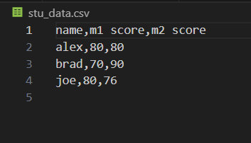

**JSON:**

JSON stands for Java script object Notation. It means that a script file which is made of text in programming language, is used to store and transfer the data.

Python supports JSON through a built-in package called json.

Output: